**Practical-10☺**

**Foodies is a restaurant established in 2020. Due to rush of customers, the waiters are not able to manage the food supply appropriately. To help them, create a menu ordering system, which allows customers to select the items from the menu and compute the total cost of their order. Use switch case for menu ordering and item selection. Menu includes the following: • Burger - ₹150 • Pizza - ₹200 • Pasta - ₹120 • Sandwich - ₹100 • French Fries - ₹80 Display the menu to user and allow them to enter the number they wish to order. Calculate the total amount after selection of all items. Ask user to enter ‘0’ after finishing the ordering of items.**

***Code:***

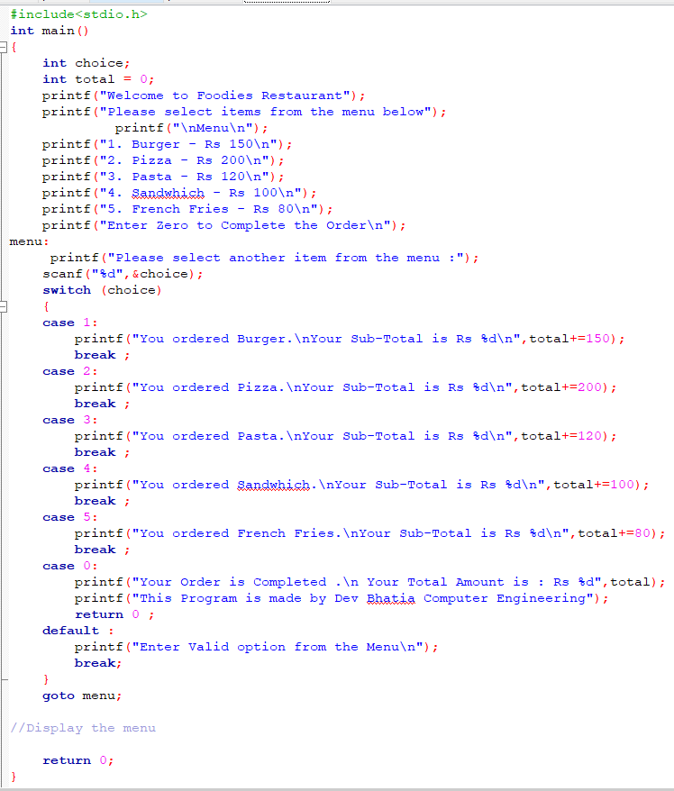**Output:-**

